aclm/oled and g/cite-d and top/10

Patentics专利检索分析报告

patentics.com

2016/12/15

.Modern Patent Analytics at your fingertips

目录
Electroluminescent device with modified thin film luminescent zone 2
Electroluminescent device with organic electroluminescent medium 4
Organic electroluminescent devices having improved power conversion efficiencies 7
Organic electroluminescent cell 10
Electroluminescent devices 12
Electroluminescent device with organic luminescent medium 16
Transparent contacts for organic devices 19
Very high efficiency organic light emitting devices based on electrophosphorescence 27
White light-emitting organic electroluminescent devices 29
Organic electroluminescent multicolor image display device 32
主权项修订统计 36

Electroluminescent device with modified thin film luminescent zone

公开号 | US4769292 | 公开日 | 1988/09/06
申请号 | 07/108,342 | 申请日 | 1987/10/14
授权日 | 1988/09/06 | 优先日 | 1987/03/02
申请人 | 伊斯曼柯达 | 标准 申请人 | 伊斯曼柯达
专利权人 | 伊斯曼柯达 | 发明人 | Tang; Ching W. | Chen; Chin H. | Goswami; Ramanuj
国际 主分类 | H01L 51/05 | 优先 国家 | US
代理 | Thomas; Carl O.

价值谱 | v1:100  v2:95  v3:9634 | 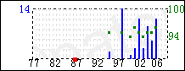 | 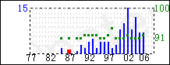
 |  | 主谱 | 参考谱:4,914,001

摘要
An electroluminescent device is disclosed having a luminescent zone of less than one μm in thickness comprised of an organic host material capable of sustaining hole-electron recombination and a fluorescent material capable of emitting light in response to energy released by hole-electron recombination.

主权项 | 专利度:19  特征度:20 | 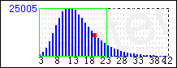
 |  | icl/H01L db/uspat

An organic electroluminescent device comprising in sequence, an anode, an organic hole injecting and transporting zone, a luminescent zone, and a cathode,
characterized in that
said luminescent zone is formed of a thin film of less than 1 μm in thickness comprised of
an organic host material forming a layer capable of sustaining both hole and electron injection and
located in said layer as a fluorescent material a dye capable of emitting light in response to hole-electron recombination, said dye having a bandgap no greater than that of said host material and a reduction potential less negative than that of said host material.

被引用 | 5574 | 自引用 | 1506 | 公司数 | 248 | 国家数 | 8 | 影响力 | 3121.89

同族数 | 8 | 国家数 | 6

法律 状态 | 无效 | 法律 描述 |  | 诉讼 信息

Electroluminescent device with organic electroluminescent medium

公开号 | US5061569 | 公开日 | 1991/10/29
申请号 | 07/561,552 | 申请日 | 1990/07/26
授权日 | 1991/10/29 | 优先日 | 1990/07/26
申请人 | 伊斯曼柯达 | 标准 申请人 | 伊斯曼柯达
专利权人 | 全球oled科技有限责任公司 | 发明人 | VanSlyke; Steven A. | Tang; Ching W. | O'Brien; Michael E. | Chen; Chin H.
国际 主分类 | C09K 11/06 | 优先 国家 | US
代理 | Thomas; Carl O.

价值谱 | v1:100  v2:96  v3:9714 | 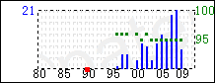 | 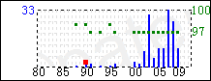
 |  | 主谱 | 参考谱:5,059,863

摘要 | 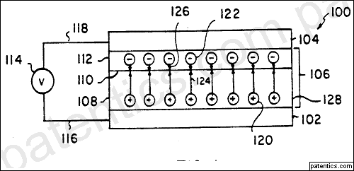
An internal junction organic electroluminescent device is disclosed comprising in sequence, an anode, an organic hold injecting and transporting zone, an organic electron injecting and transporting zone, and a cathode. The hole injecting and transporting zone includes a tertiary amine containing at least two tertiary amine moieties and including attached to a tertiary amine nitrogen atom an aromatic moiety containing at least two fused aromatic rings.

主权项 | 专利度:23  特征度:14 | 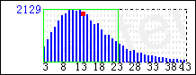
 |  | icl/C09K db/uspat

An internal junction organic electroluminescent device comprising in sequence, an anode, an organic hole injecting and transporting zone comprised of a layer containing a hole transporting aromatic tertiary amine, an organic electron injecting and transporting zone, and a cathode, characterized in that
said hole transporting aromatic tertiary amine is comprised of at least two tertiary amine moieties and includes attached to a tertiary amine nitrogen atom an aromatic moiety containing at least two fused aromatic rings.

被引用 | 4549 | 自引用 | 1198 | 公司数 | 127 | 国家数 | 8 | 影响力 | 2019.1

同族数 | 9 | 国家数 | 7

法律 状态 | 无效 | 法律 描述 |  | 诉讼 信息

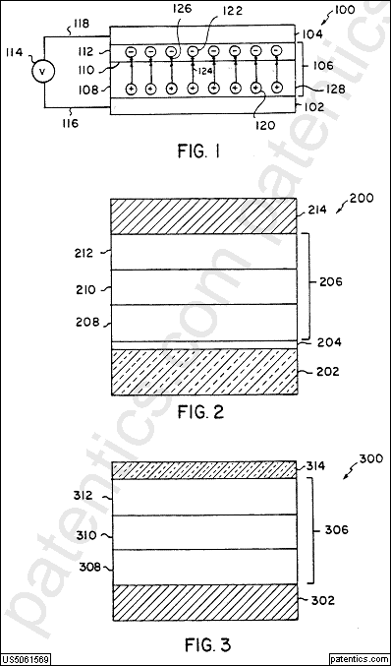

Organic electroluminescent devices having improved power conversion efficiencies

公开号 | US4539507 | 公开日 | 1985/09/03
申请号 | 06/478,938 | 申请日 | 1983/03/25
授权日 | 1985/09/03 | 优先日 | 1983/03/25
申请人 | 伊斯曼柯达 | 标准 申请人 | 伊斯曼柯达
专利权人 | 伊斯曼柯达 | 发明人 | VanSlyke; Steven A. | Tang; Ching W.
国际 主分类 | C09K 11/06 | 优先 国家 | US
代理 | Schmidt; Dana M.

价值谱 | v1:100  v2:93  v3:9364 | 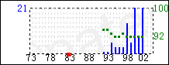 | 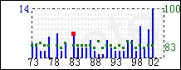
 |  | 主谱 | 参考谱:4,628,227

摘要 | 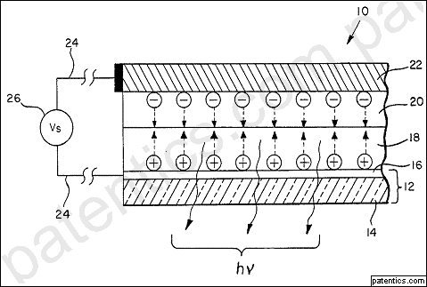
Electroluminescent devices are disclosed comprising a hole-injecting zone and an adjacent organic luminescent zone, the device having a power conversion efficiency of at least 9×10-5 w/w and said zones having a combined thickness no greater than about 1 micron.

主权项 | 专利度:9  特征度:18 | 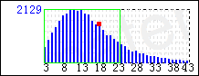
 |  | icl/C09K db/uspat

In an electroluminescent device comprising, in sequence, an anode electrode, a hole-injecting zone, an organic luminescent zone, and a cathode electrode, at least one of said electrodes being capable of transmitting at least 80% of radiation having wavelengths longer than 400 nm,
the improvement wherein said luminescent zone comprises an electron-transporting compound that provides a maximum electroluminescent quantum efficiency of at least about 5×10-4 photons/electron, when used in a test device driven at no more than the lesser of (i) 25 volts and (ii) the voltage which produces the maximum power conversion efficiency of said device, said test device comprising (1) a hole-injecting zone consisting essentially of 1,1-bis-(4-di-p-tolylaminophenyl)cyclohexane, said hole-injecting zone and said luminescent zone having a combined thickness of no more than 1 micron, (2) an anode electrode that transmits at least 80% of radiation having wavelengths longer than 400 nm, and (3) an indium cathode,
and wherein said device has a power conversion efficiency of at least 9×10-5 w/w and said zones have a combined thickness that is no greater than about 1 micron.

被引用 | 5226 | 自引用 | 1071 | 公司数 | 266 | 国家数 | 9 | 影响力 | 3721.61

同族数 | 7 | 国家数 | 6

法律 状态 | 无效 | 法律 描述 |  | 诉讼 信息

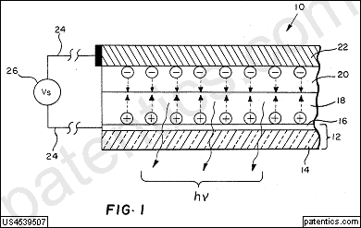 | 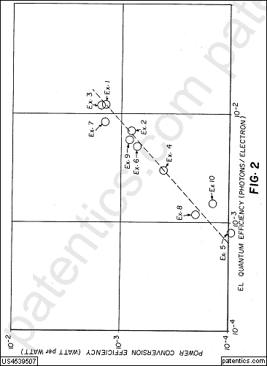

Organic electroluminescent cell

公开号 | US4356429 | 公开日 | 1982/10/26
申请号 | 06/169,705 | 申请日 | 1980/07/17
授权日 | 1982/10/26 | 优先日 | 1980/07/17
申请人 | 伊斯曼柯达 | 标准 申请人 | 伊斯曼柯达
专利权人 | 伊斯曼柯达 | 发明人 | Tang; Ching W.
国际 主分类 | H05B 33/14 | 优先 国家 | US
代理 | Schmidt; Dana M.

价值谱 | v1:98  v2:2200  v3:0 | 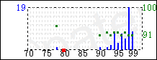 | 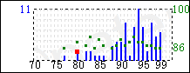
 |  | 主谱 | 参考谱:4,375,318

摘要 | 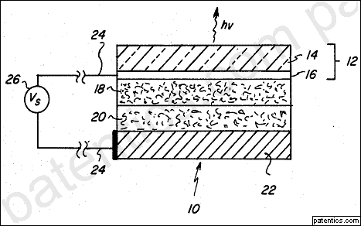
An organic electroluminescent cell is disclosed comprising a luminescent zone between two electrodes, wherein a hole-injecting zone comprising a porphyrinic compound is disposed between the luminescent zone and the anode electrode.

主权项 | 专利度:5  特征度:11 | 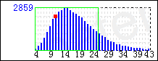
 |  | icl/H05B db/uspat

In an electroluminescent cell including an anode electrode, a cathode electrode, and a luminescent zone between said electrodes comprising an organic luminescent agent and a binder having a breakdown field strength of at least about 105 volt/cm,
the improvement comprising, between said luminescent zone and said anode electrode, a hole-injecting zone comprising a layer of a porphyrinic compound.

被引用 | 3972 | 自引用 | 1078 | 公司数 | 210 | 国家数 | 8 | 影响力 | 4747.95

同族数 | 4 | 国家数 | 4

法律 状态 | 无效 | 法律 描述 |  | 诉讼 信息

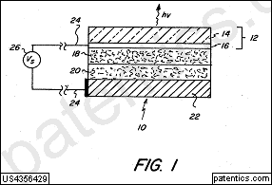

Electroluminescent devices

公开号 | US5247190 | 公开日 | 1993/09/21
申请号 | 07/634,117 | 申请日 | 1990/12/28
授权日 | 1993/09/21 | 优先日 | 1989/04/20
申请人 | Cambridge Research and Innovation Limited | Cambridge Capital Management Limited | Lynxvale Limited | 标准 申请人 | cambridge research instrumentation | cambridge capital management | lynxvale
专利权人 | cambridge display technology | 发明人 | Friend; Richard H. | Burroughes; Jeremy H. | Bradley; Donal D.
国际 主分类 | C09K 11/06 | 优先 国家 | GB
代理 | Merchant, Gould, Smith, Edell, Welter & Schmidt

价值谱 | v1:100  v2:92  v3:9346 | 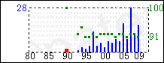 | 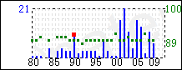
 |  | 主谱 | 参考谱:5,100,523

摘要 | 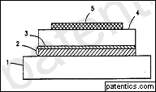
An electroluminescent device comprises a semiconductor layer (4) in the form of a thin dense polymer film comprising at least one conjugated polymer, a first contact layer (5) in contact with a first surface of the semiconductor layer, and a second contact layer (3) in contact with a second surface of the semiconductor layer. The polymer firm (4) of the semiconductor layer has a sufficiently low concentration of extrinsic charge carriers that on applying an electric field between the first and second contact layers across the semiconductor layer so as to render the second contact layer positive relative to the first contact layer charge carriers are injected into the semiconductor layer and radiation is emitted from the semiconductor layer. The polymer film can be poly(p-phenyenevinylene) [PPV] of formula (I) wherein the phenylene ring may optionally carry one or more substituents each independently selected from alkyl (preferably methyl), alkoxy (preferably methoxy or ethoxy), halogen (preferably chlorine or bromine) or nitro.

主权项 | 专利度:14  特征度:16 | 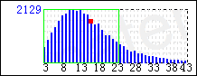
 |  | icl/C09K db/uspat

An electroluminescent device comprising:
a semiconductor layer in the form of a thin dense polymer film comprising at least one conjugated polymer;
a first contact layer which is selected so that on application of an electric field to said device charge carriers of a first type are injected into the semiconductor layer; and
a second contact layer which is selected so that on application of an electric field to said device charge carriers of a second type are injected into the semiconductor layers, wherein the polymer film of the semiconductor layer has a sufficiently low concentration of extrinsic charge carriers that on applying an electric field between the first and second contact layers across the semiconductor layer so as to render the second contact layer positive relative to the first contact layer charge carriers of said first and second types are injected into the semiconductor layer and combine to form in the conjugated polymer charge carrier pairs which decay radiatively so that radiation is emitted from the conjugated polymer.

被引用 | 4660 | 自引用 | 0 | 公司数 | 212 | 国家数 | 12 | 影响力 | 2436.72

同族数 | 25 | 国家数 | 15

法律 状态 | 无效 | 法律 描述 |  | 诉讼 信息

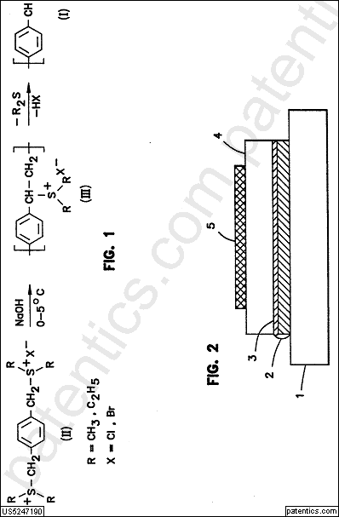 | 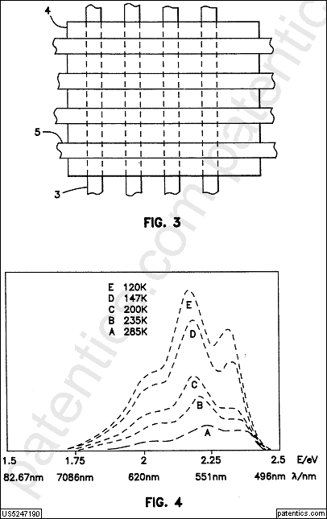
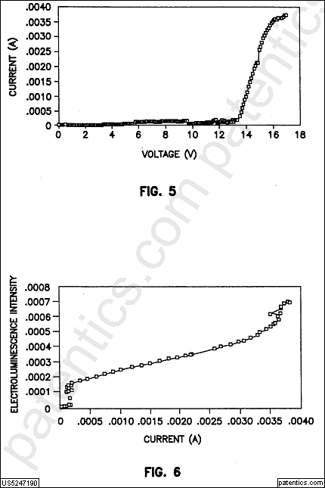 | 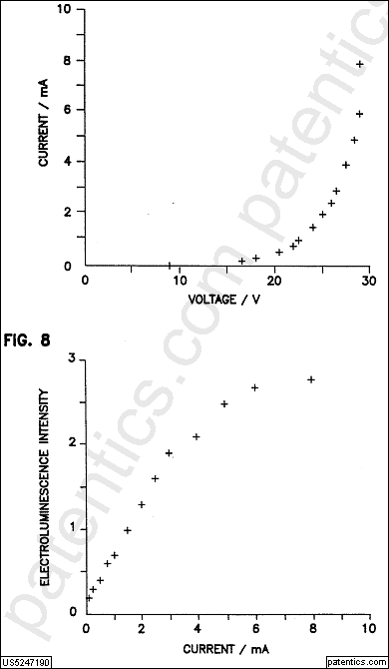

Electroluminescent device with organic luminescent medium

公开号 | US4720432 | 公开日 | 1988/01/19
申请号 | 07/013,528 | 申请日 | 1987/02/11
授权日 | 1988/01/19 | 优先日 | 1987/02/11
申请人 | 伊斯曼柯达 | 标准 申请人 | 伊斯曼柯达
专利权人 | 伊斯曼柯达 | 发明人 | VanSlyke; Steven A. | Tang; Ching W. | Roberts; Luther C.
国际 主分类 | C09K 11/06 | 优先 国家 | US
代理 | Thomas; Carl O.

价值谱 | v1:100  v2:94  v3:9508 | 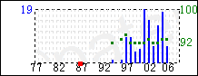 | 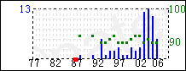
 |  | 主谱 | 参考谱:4,734,338

摘要 | 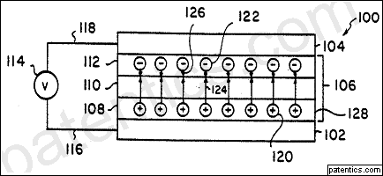
An electroluminescent device is disclosed comprising in sequence, an anode, an organic hole injecting and transporting zone, an organic electron injecting and transporting zone, and a cathode. The organic hole injecting and transporting zone is comprised of a layer in contact with the anode containing a hole injecting porphyrinic compound and a layer containing a hole transporting aromatic tertiary amine interposed between the hole injecting layer and the electron injecting and transporting zone.

主权项 | 专利度:20  特征度:13 | 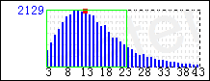
 |  | icl/C09K db/uspat

An electroluminescent device comprising in sequence, an anode, an organic hole injecting and transporting zone, an organic electron injecting and transporting zone, and a cathode, characterized in that
said organic hole injecting and transporting zone is comprised of
a layer in contact with said anode containing a hole injecting porphyrinic compound and
a layer containing a hole transporting aromatic tertiary amine interposed between said hole injecting layer and said electron injecting and transporting zone.

被引用 | 3168 | 自引用 | 1093 | 公司数 | 152 | 国家数 | 9 | 影响力 | 1567.19

同族数 | 8 | 国家数 | 6

法律 状态 | 无效 | 法律 描述 |  | 诉讼 信息

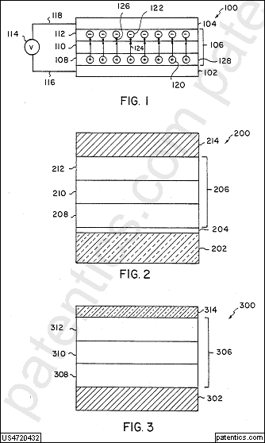 | 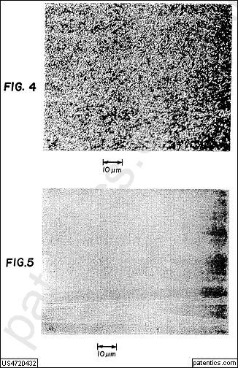

Transparent contacts for organic devices

公开号 | US5703436 | 公开日 | 1997/12/30
申请号 | 08/613,207 | 申请日 | 1996/03/06
授权日 | 1997/12/30 | 优先日 | 1996/03/06
申请人 | 普林斯顿大学 | 标准 申请人 | 普林斯顿大学
专利权人 | *trustees of princeton university the | 发明人 | Forrest; Stephen R. | Thompson; Mark E. | Burrows; Paul E. | Bulovic; Vladimir | Gu; Gong
国际 主分类 | C09K 11/06 | 优先 国家 | US
代理 | Watov & Kipnes, P. C.

价值谱 | v1:98  v2:98  v3:828 | 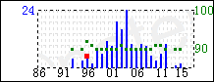 | 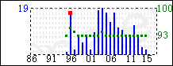
 |  | 主谱 | 参考谱:6,600,175

摘要 | 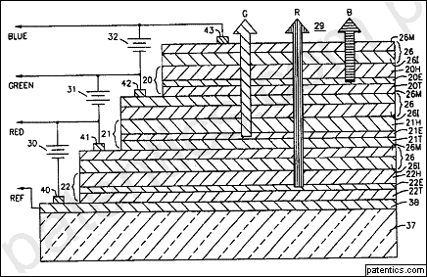
A multicolor organic light emitting device employs vertically stacked layers of double heterostructure devices which are fabricated from organic compounds. The vertical stacked structure is formed on a glass base having a transparent coating of ITO or similar metal to provide a substrate. Deposited on the substrate is the vertical stacked arrangement of three double heterostructure devices, each fabricated from a suitable organic material. Stacking is implemented such that the double heterostructure with the longest wavelength is on the top of the stack. This constitutes the device emitting red light on the top with the device having the shortest wavelength, namely, the device emitting blue light, on the bottom of the stack. Located between the red and blue device structures is the green device structure. The devices are configured as stacked to provide a staircase profile whereby each device is separated from the other by a thin transparent conductive contact layer to enable light emanating from each of the devices to pass through the semitransparent contacts and through the lower device structures while further enabling each of the devices to receive a selective bias. The devices are substantially transparent when de-energized, making them useful for heads-up display applications.

主权项 | 专利度:29  特征度:27 | 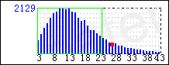
 |  | icl/C09K db/uspat

A light emitting device including at least one organic light emitting device (OLED) that is substantially transparent (TOLED) when de-energized, comprising:
a substantially transparent substrate having top and bottom surfaces;
a first substantially transparent thin film coating of indium tin oxide (ITO) applied to the top surface of said substrate;
a substantially transparent coating of a hole conducting material applied over said ITO layer;
a substantially transparent layer of an electron conducting and highly electroluminescent organic material overlaying said ITO layer;
a relatively thin film of a substantially transparent metal electrode applied over said organic material layer;
a second substantially transparent thin film coating of ITO overlying said metal electrode film; and
first and second electrical contacts bonded to said first and second ITO layers for receiving a bias voltage to energize said device, and cause it to emit light of a given color from top and bottom surfaces thereof.

被引用 | 3574 | 自引用 | 316 | 公司数 | 182 | 国家数 | 9 | 影响力 | 1407.13

同族数 | 30 | 国家数 | 15

法律 状态 | 无效 | 法律 描述 |  | 诉讼 信息

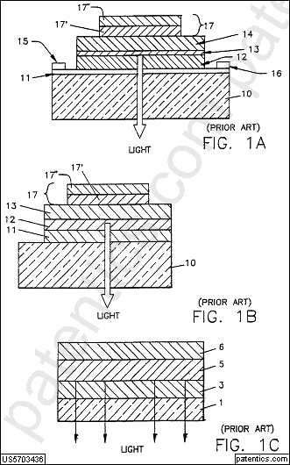 | 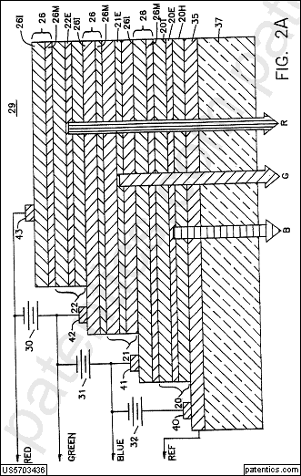
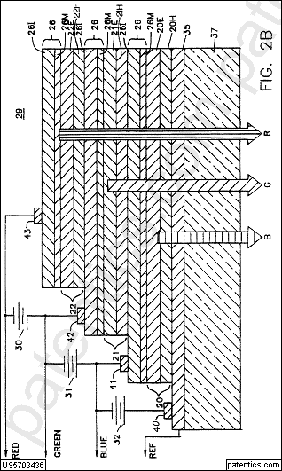 | 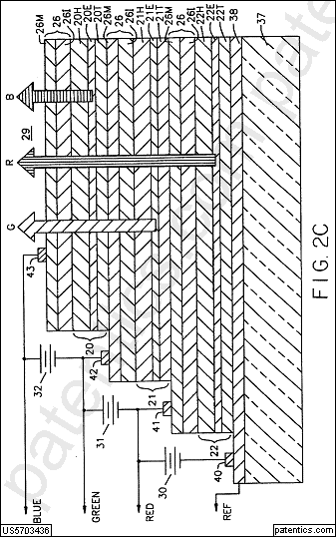
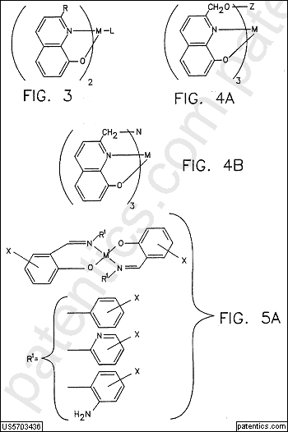 | 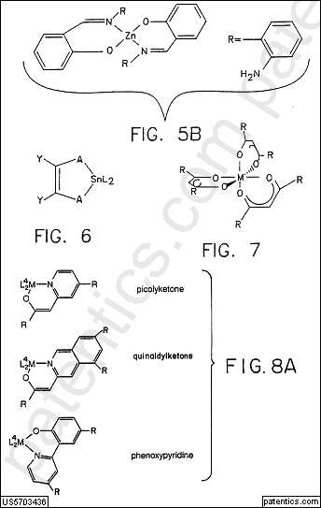
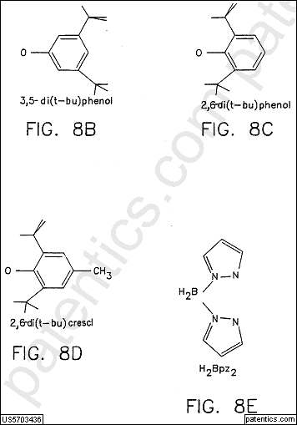 | 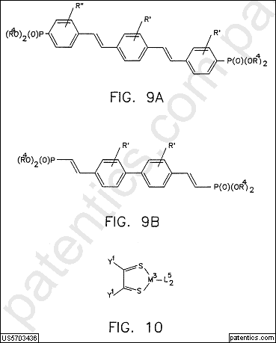
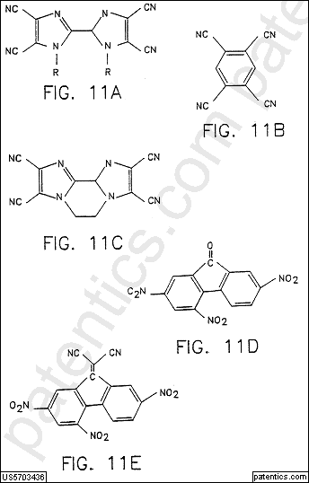 | 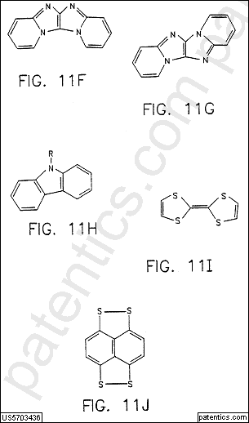
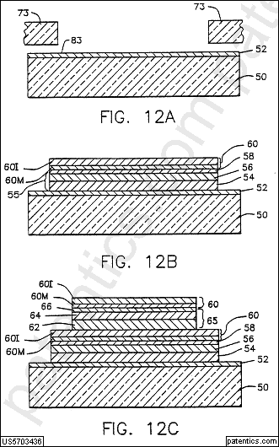 | 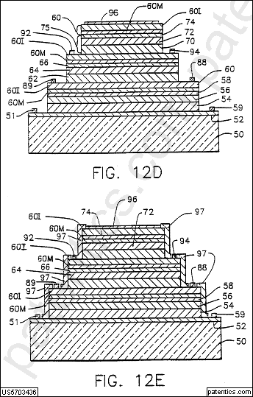
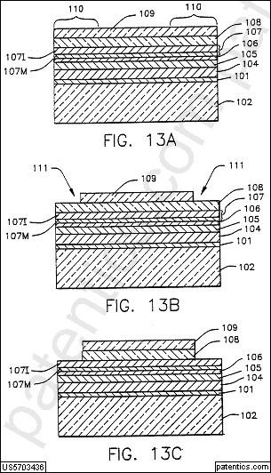 | 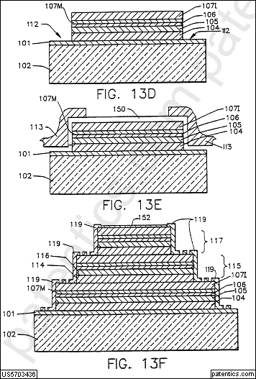
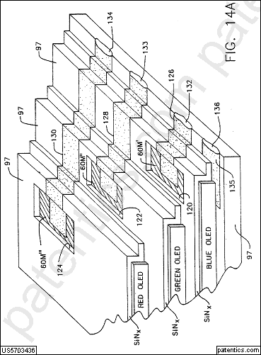 | 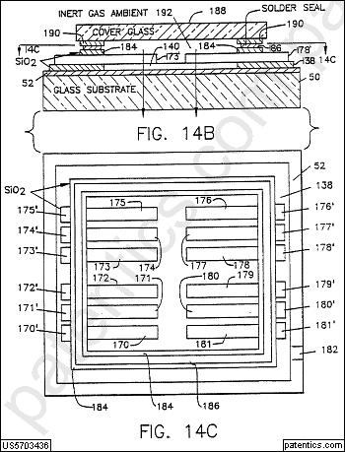
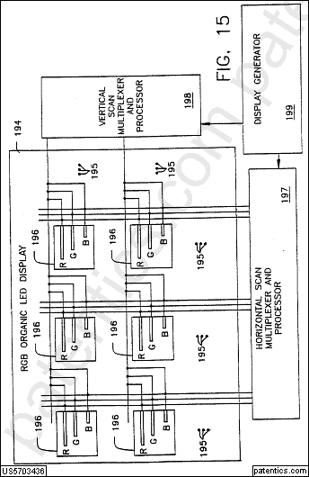 | 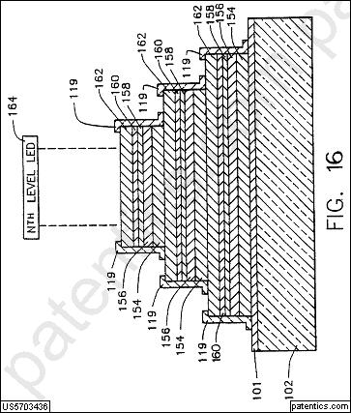
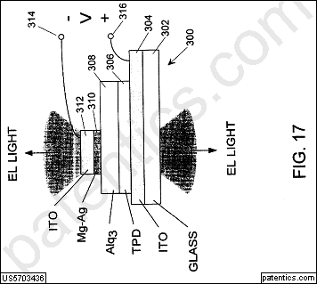 | 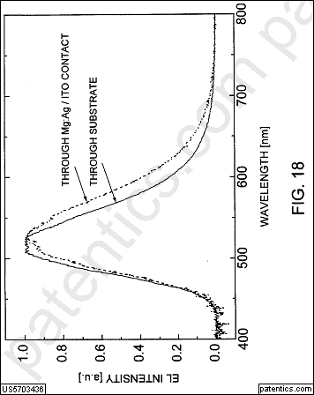
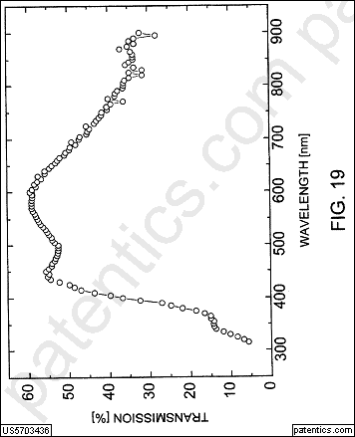 | 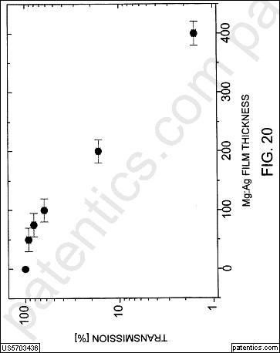
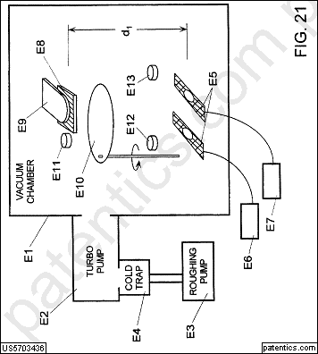 | 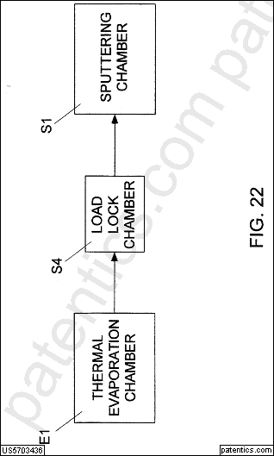
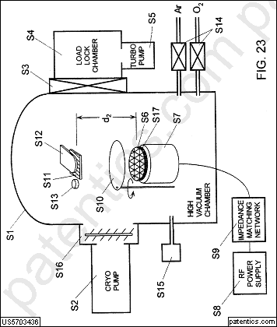

Very high efficiency organic light emitting devices based on electrophosphorescence

公开号 | WO2000070655 | 公开日 | 2000/11/23
申请号 | PCT/US2000/01294.6 | 申请日 | 2000/05/11
申请人 | 普林斯顿大学 | 南加州大学 | 标准 申请人 | 普林斯顿大学 | 南加州大学
专利权人 |  | 发明人 | Baldo,Marc A. | Burrows,Paul E. | Forrest,Stephen R. | Thompson,Mark E. | Lamansky,Sergey
国际 主分类 | C07F 15/00 | 优先 国家 | US
代理 | Kenyon &Kenyon,One Broadway New York,NY,10004,US

价值谱 | v1:0  v2:0  v3:0

摘要
Organic light emitting devices are described wherein the emissive layer comprises a host material containing an emissive molecule, which molecule is adapted to luminesce when a voltage is applied across the heterostructure, and the emissive molecule is selected from the group of phosphorescent organometallic compounds, including cyclometallated iridium compounds and wherein the devices contain an exciton blocking layer.

主权项 | 专利度:30  特征度:10 | 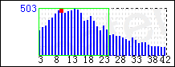
 |  | icl/C07F db/eppat

An electroluminescent layer comprising an emissive layer including an emissive molecule that is a phosphorescent organometallic iridium compound or a phosphorescent organometallic osmium compound.

被引用 | 3825 | 自引用 | 3 | 公司数 | 88 | 国家数 | 8 | 影响力 | 1707.67

同族数 | 30 | 国家数 | 11

法律 状态 | (null) | 法律 描述 |  | 诉讼 信息

White light-emitting organic electroluminescent devices

公开号 | US5683823 | 公开日 | 1997/11/04
申请号 | 08/592,830 | 申请日 | 1996/01/26
授权日 | 1997/11/04 | 优先日 | 1996/01/26
申请人 | 伊斯曼柯达 | 标准 申请人 | 伊斯曼柯达
专利权人 | 全球oled科技有限责任公司 | 发明人 | Shi; Jianmin | Tang; Ching Wan
国际 主分类 | C09K 11/06 | 优先 国家 | US
代理 | Owens; Raymond L.

价值谱 | v1:100  v2:97  v3:200 | 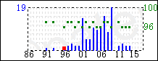 | 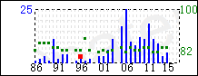
 |  | 主谱 | 参考谱:5,786,089

摘要 | 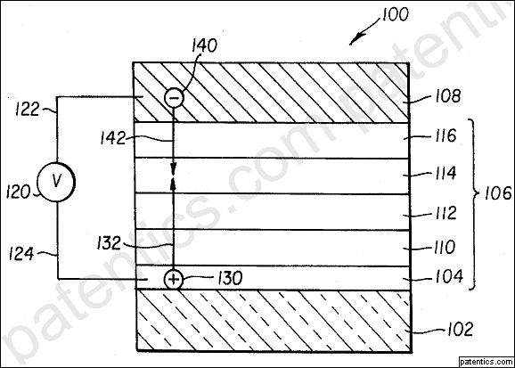
An electroluminescent device includes an anode, a positive-hole transporting layer made of an organic compound, a fluorescent emitting layer made of an organic compound, a cathode. The fluorescent emitting layer includes a red light emitting material uniformly dispersed in a host emitting material. The host emitting material being adapted to emit in the blue green regions so that the light produced by this device is substantially white.

主权项 | 专利度:5  特征度:26 | 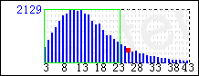
 |  | icl/C09K db/uspat

A white light emitting electroluminescent device, comprising:
a) an anode;
b) a hole transporting layer made of an organic compound;
c) a luminescent layer including a host material and a guest component uniformly dispersed in the host material;
d) a cathode;
e) said host material being selected to emit blue-green light; and
f) the guest component being selected to emit red light and has the following formula and a concentration in the host material in the range of from 0.01 to 10% by mole ratio: ##STR15## wherein R1 -R8, which may be the same or different, are hydrogen, halogen, or alkyl, alkoxy, alkenyl, cycloalkyl, arylalkyl, acyl, wherein the alkyl portions each containing fewer than 24 carbons, or aryl heteroaryl, alone or in combination.

被引用 | 1521 | 自引用 | 944 | 公司数 | 55 | 国家数 | 8 | 影响力 | 296.92

同族数 | 7 | 国家数 | 5

法律 状态 | 无效 | 法律 描述 |  | 诉讼 信息

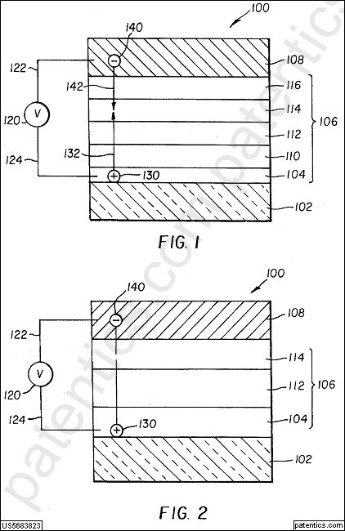

Organic electroluminescent multicolor image display device

公开号 | US5294870 | 公开日 | 1994/03/15
申请号 | 07/814,553 | 申请日 | 1991/12/30
授权日 | 1994/03/15 | 优先日 | 1991/12/30
申请人 | 伊斯曼柯达 | 标准 申请人 | 伊斯曼柯达
专利权人 | 全球oled科技有限责任公司 | 发明人 | Tang; Ching W. | Williams; David J. | Chang; Jack C.
国际 主分类 | C09K 11/06 | 优先 国家 | US
代理 | Walker; Robert L.

价值谱 | v1:100  v2:91  v3:9282 | 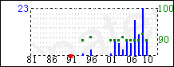 | 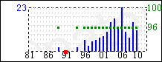
 |  | 主谱 | 参考谱:5,256,945

摘要 | 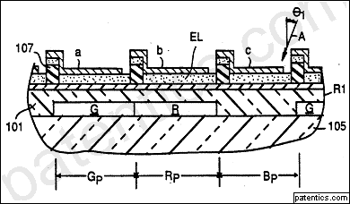
An organic electroluminescent multicolor image display device is disclosed containing an image display array made up of a plurality of light emitting pixels arranged in intersecting files (rows and columns). Each pixel contains a light transmissive first electrode, an electroluminescent medium overlying the first electrode, and an overlying second electrode. The electrodes connect the pixels in an X-Y addressing pattern. The organic electroluminescent medium emits in the blue region of the spectrum. Each pixel is divided into at least two sub-pixels. The electrodes of one set of parallel files is divided into at least two laterally spaced elements each of which joins and forms a part of one sub-pixel of each pixel in the same file. A fluorescent medium capable of absorbing light emitted by the electroluminescent medium and emitting at a longer wavelength is positioned to receive emitted light from the first electrode means. The fluorescent medium is confined to only one of the sub-pixels of each pixel.

主权项 | 专利度:11  特征度:30 | 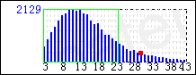
 |  | icl/C09K db/uspat

An image display device comprised of an array consisting of
a plurality of light emitting pixels arranged in two intersecting sets of parallel files, the pixels in a first set of parallel files forming columns and the pixels in a second set of parallel files forming rows on an electrically insulative support,
the pixels in each file of said first set of parallel files containing and being joined by a common light transmissive first electrode means overlying said support,
the first electrode means in adjacent files of said first set being laterally spaced on said support,
an organic electroluminescent medium overlying the first electrode means and said support,
the pixels in each file of said second set of parallel files containing and being joined by a common second electrode means overlying said organic electroluminescent medium, and
the second electrode means in adjacent files of said second set being laterally spaced on said organic electroluminescent medium,
characterized in that the device is capable of producing multicolor image display,
said organic electroluminescent medium emits in the blue region of the spectrum and has a peak emission at a wavelength of less than 480 nm,
each pixel in said first set of parallel files of pixels is divided into at least two subpixels,
in said first set one of said first and second electrode means that is contained in and joins the pixels in each file of said first set is divided into at least two laterally spaced electrode elements, each of the electrode elements joining and forming a part of one sub-pixel of each of the pixels in a file, and
a fluorescent medium located on the upper surface of said support and underlying the first electrode means, and capable of absorbing light emitted by said organic electroluminescent medium and emitting at a longer wavelength is positioned to receive emitted light from said organic electroluminescent medium transmitted through the first electrode means, said fluorescent medium being confined to one sub-pixel of each of the pixels in a file.

被引用 | 1969 | 自引用 | 750 | 公司数 | 122 | 国家数 | 10 | 影响力 | 917.98

同族数 | 9 | 国家数 | 6

法律 状态 | 无效 | 法律 描述 |  | 诉讼 信息

主权项修订统计

总计10篇；
无对比10篇
对比0篇
主权项修订0篇；
主权项插入0处；
主权项删除0处；
主权项保留0处；
主权项无修订0篇。

